Phase 1: Idea Phase Document

Automated Employee Data Migration in Service Now using Transform Maps

1. Project Objective
Automate the migration of employee datasets from external spreadsheet files (.xlsx) into the ServiceNow platform using Import Sets and Transform Maps.
The primary goal is to establish a repeatable, scalable, and error-resistant data ingestion workflow that standardizes incoming personnel records and reduces manual administrative overhead.

2. Problem Statement
Organizations frequently rely on manual data entry or ad-hoc file imports to update employee records within ServiceNow. This introduces critical operational liabilities:

- High Risk of Human Error: Typos, incorrect formatting, and misplaced field values.
- Data Inconsistency: Non-standardized data formats (e.g., Department naming, Email structure) degrade searchability and reporting accuracy.
- Process Inefficiency: Hours spent processing individual spreadsheet updates manually.
- Duplicate Record Creation: Manual re-imports create duplicate records, degrading database integrity.

3. Proposed Architecture & Solution Workflow
Build an automated staging and transformation pipeline using ServiceNow Import Sets and Transform Maps.

1. Source File Preparation
- Employee ID: Primary key e.g., SB-0001, SB-0002
- Name: e.g., Ratan Kumar, Sandeep Gupta
- Email: e.g., test1@gmail.com, test2@gmail.com
- Department: e.g., ServiceNow, Salesforce
- Location: e.g., Hyderabad

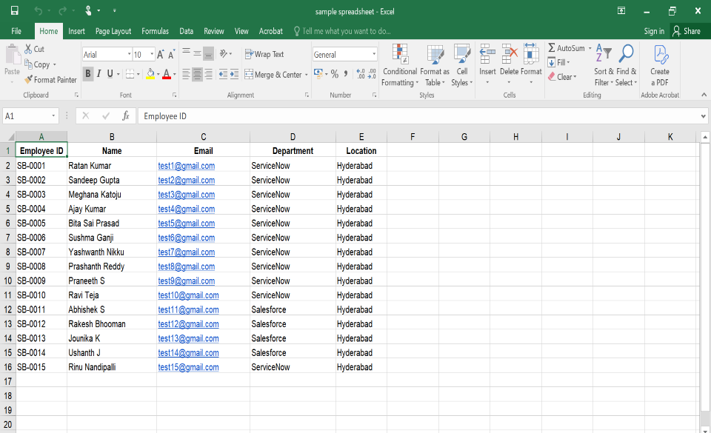

2. ServiceNow Platform Navigation
Navigate via the ServiceNow filter navigator to:
System Import Sets > Load Data

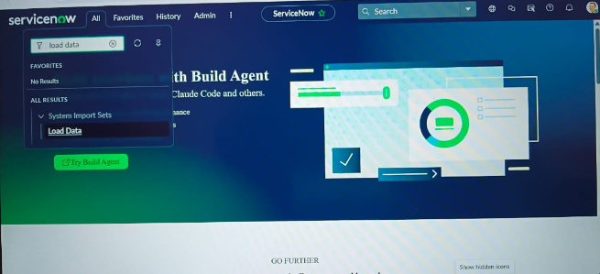
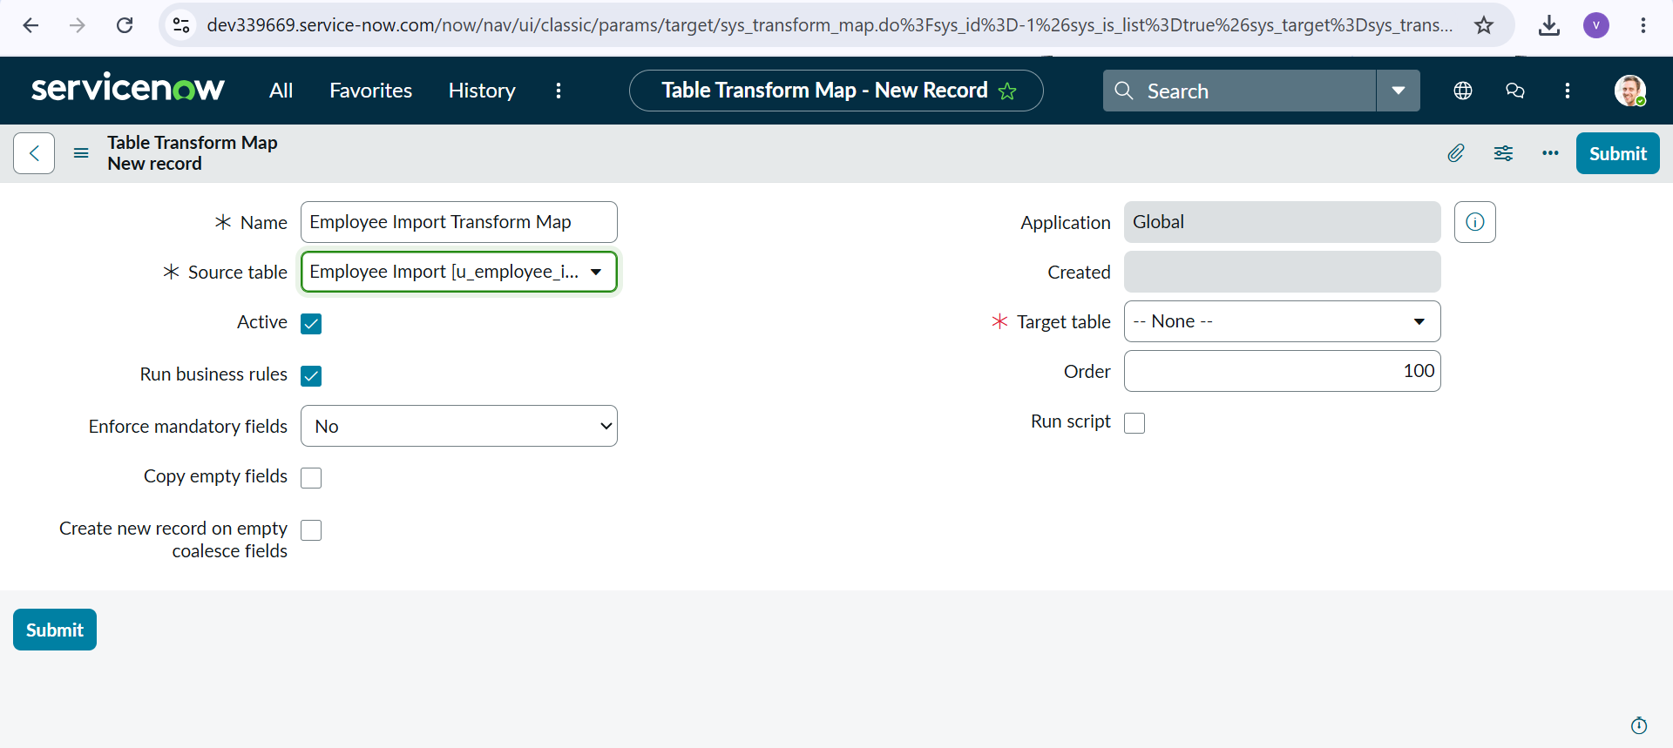

3. Ingestion & Staging Execution
The system executes file processing:
- Name: ImportProcessor
- State: Complete
- Completion Code: Success
- Progress Summary: Processed: 15, inserts: 15, updates: 0, errors: 0
Staging Table Created: u_employee_import
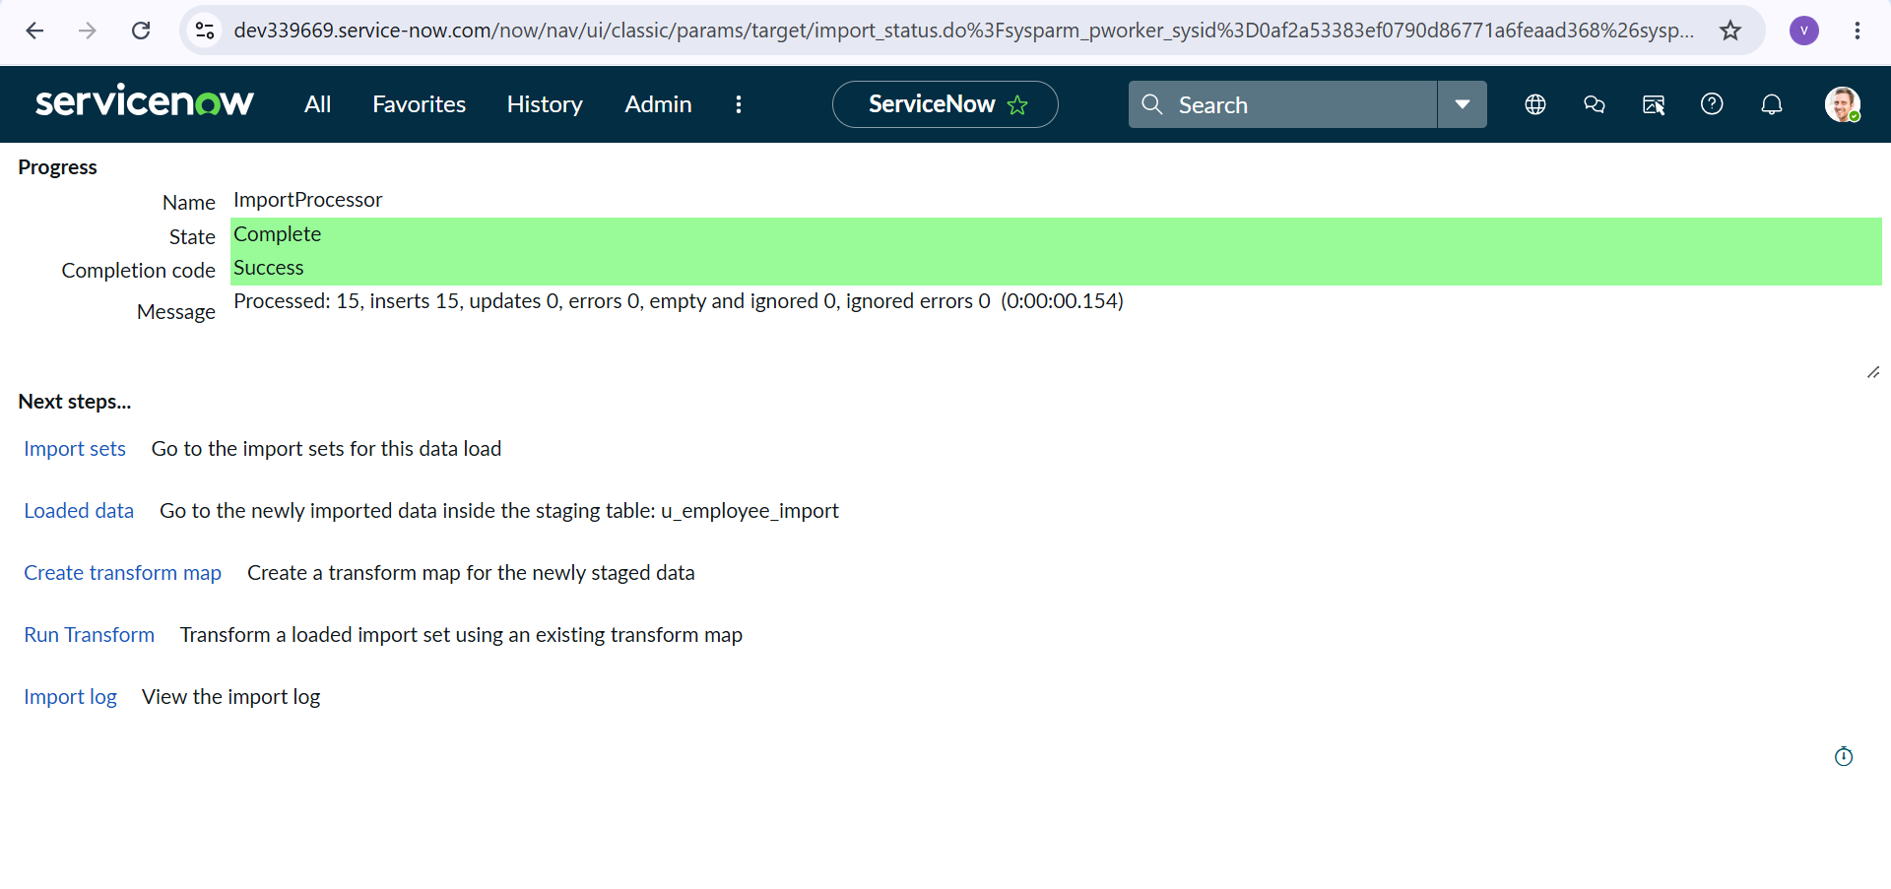

4. Staging Data Verification
The staging list view (u_employee_import_list) tracks all loaded rows:
- Total records: 1 to 20 of 10

